Trace Browser Export

m000.spc
Folder: V:\tttr-data\bh\bh_spc132_sm_dna
Rating: 0
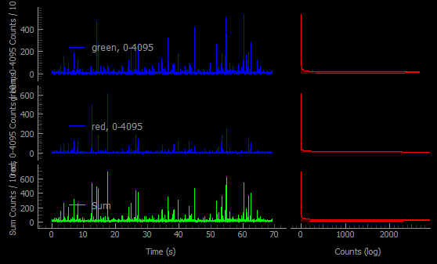

m001.spc
Folder: V:\tttr-data\bh\bh_spc132_sm_dna
Rating: 0
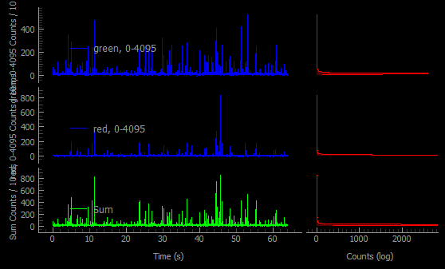

m002.spc
Folder: V:\tttr-data\bh\bh_spc132_sm_dna
Rating: 0
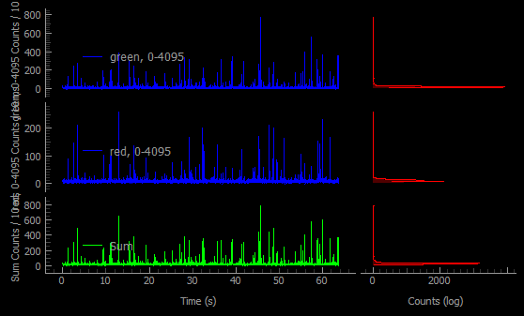

m003.spc
Folder: V:\tttr-data\bh\bh_spc132_sm_dna
Rating: 0
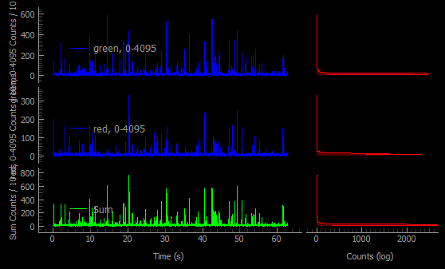

m004.spc
Folder: V:\tttr-data\bh\bh_spc132_sm_dna
Rating: 0
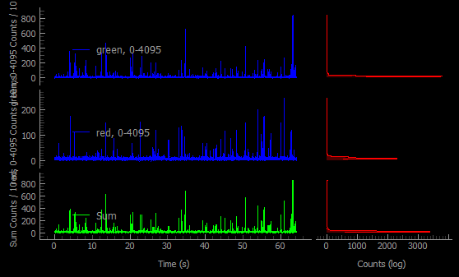

m005.spc
Folder: V:\tttr-data\bh\bh_spc132_sm_dna
Rating: 0
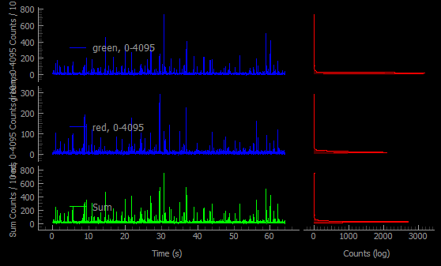

m009.spc
Folder: V:\tttr-data\bh\bh_spc132_sm_dna
Rating: 0
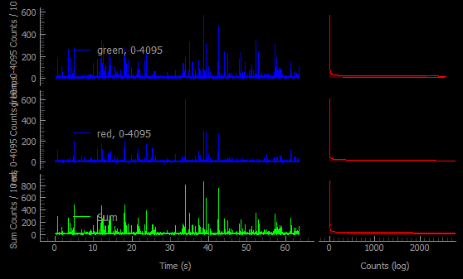

m010.spc
Folder: V:\tttr-data\bh\bh_spc132_sm_dna
Rating: 0
